Contents

1 Overview 3

2 Preparations 3

2.1 Prerequisites 3

2.2 Deployment Process 3

3 Configuring Solarwinds Server & Application Monitor 4

Monitoring Huawei Servers by Using Solarwinds Server & Application Monitor

**Keywords: monitoring, SNMP, trap**

**Abstract: This document describes how to use Solarwinds Server & Application Monitor to monitor Huawei servers.**

**Acronyms and Abbreviations: The following table lists acronyms and abbreviations used in this document.**

|  |  |
| --- | --- |
| Acronym and Abbreviation | Full Spelling |
|  |  |
|  |  |
|  |  |
|  |  |

# Overview

This document describes how to use Solarwinds Server & Application Monitor to monitor Huawei servers through SNMP.

# Preparations

## Prerequisites

Test network diagram

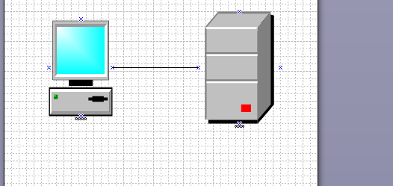

IP address configuration:

Symantec Management Console IP address: 192.168.2.112 255.255.0.0

E9000 iBMC IP address: 192.168.12.10 255.255.0.0

E9000 HMM IP address: 192.168.10.1 255.255.0.0

## Deployment Process

The steps are as follows:

Install and deploy Solarwinds Server & Application Monitor.

Set the network of Solarwinds Server & Application Monitor.

----End

**Installing and Deploying Solarwinds Server & Application Monitor**

Deploy Solarwinds Server & Application Monitor on the Windows Server 2012 OS.

You can download the software of the trial version from the official website. It is recommended that you download the offline package that included all the dependent software.

Official website: http://www.solarwinds.com/server-application-monitor

In normal cases, you can complete the installation process by clicking **Next** in sequence. In a test, the dependent .net 4.6.2 cannot be installed on the OS. To solve the problem, you need to update the OS patch.

# Configuring Solarwinds Server & Application Monitor

After the installation is complete, use the software to access the WebUI of the control end, as shown in the following figure.

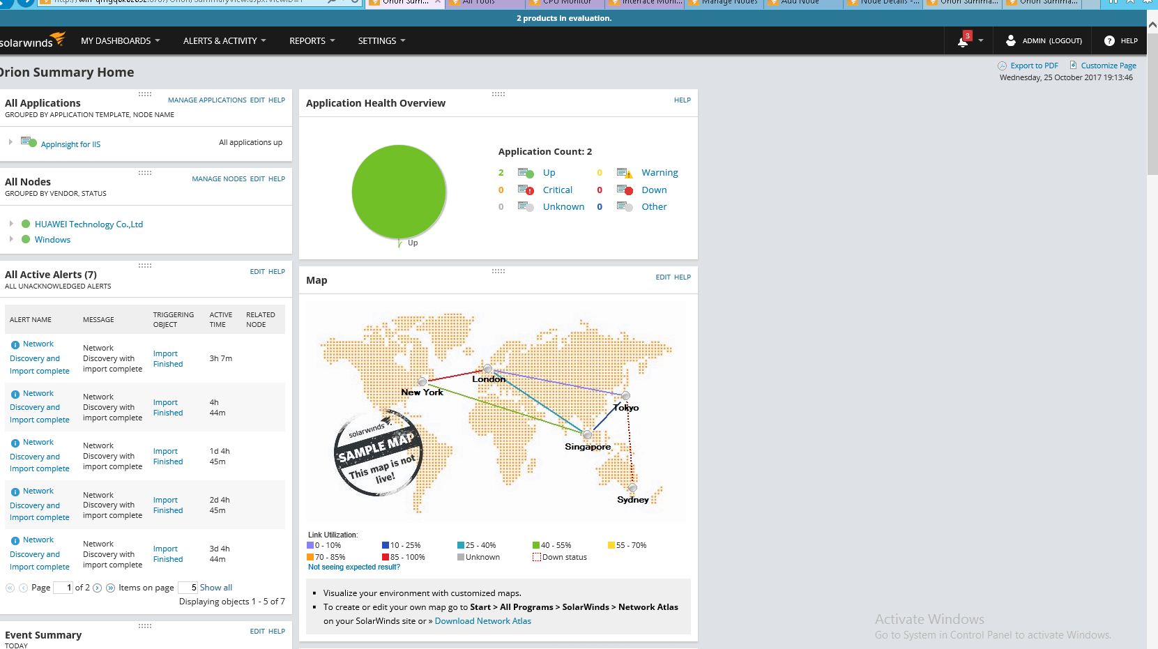

Choose **Settings** > **Network Sonar Discovery**, as shown in the following figure.

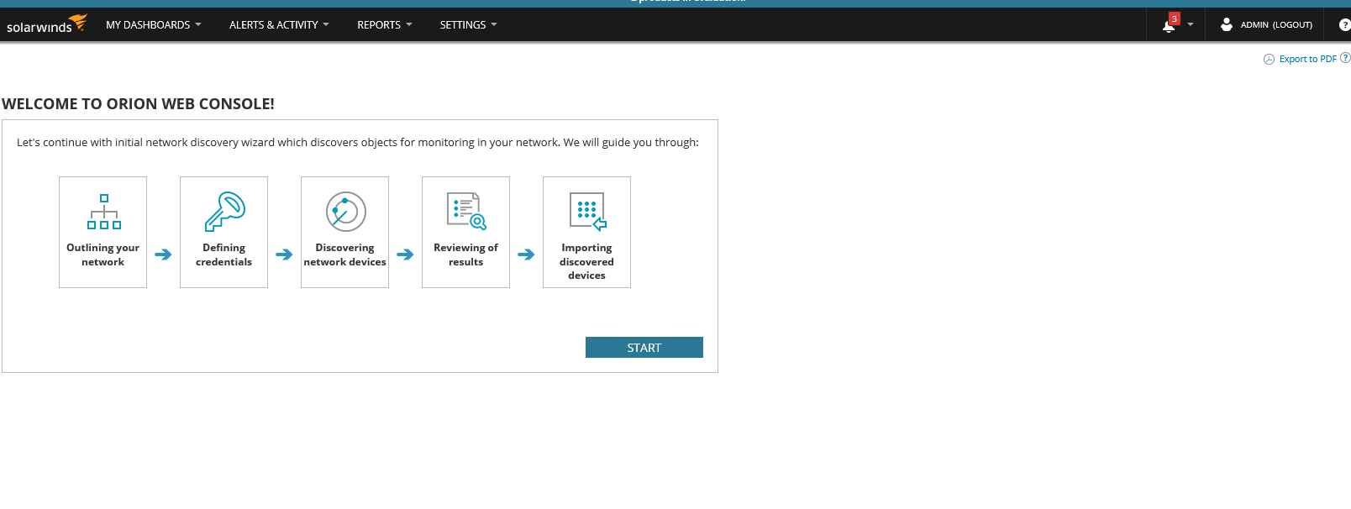

Click **Start** to perform network discovery configuration and import devices to be monitored in batches.

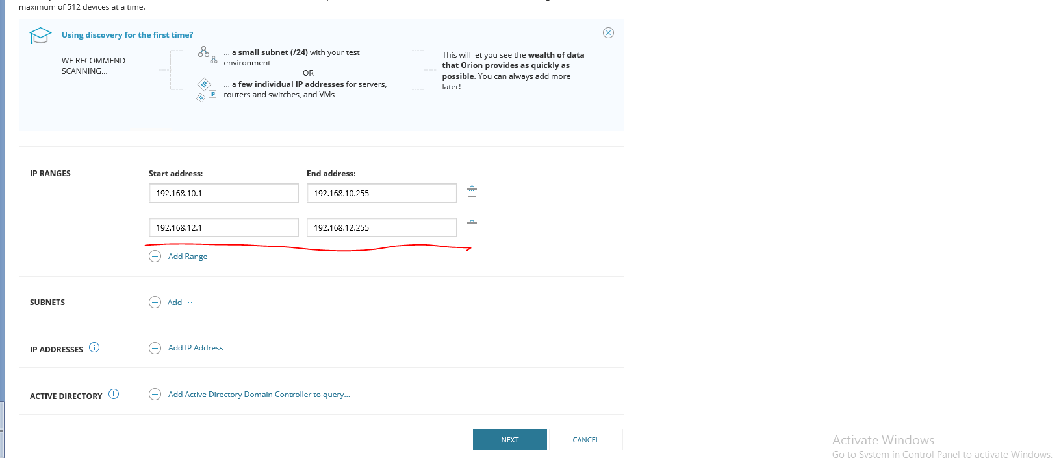

Set the community name on the **SNMP** tab.

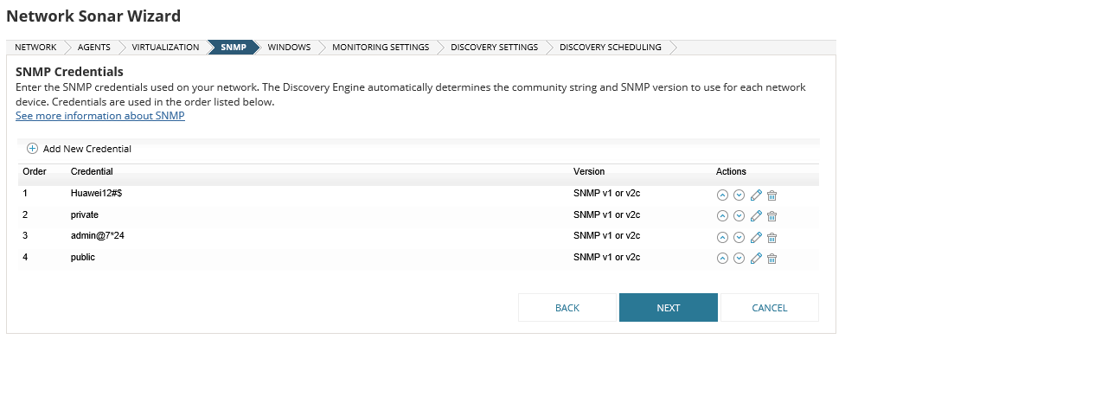

On the **MONITORING SETTINGS** tab, select **SNMP** and **Automatically monitor based on my defined monitoring settings**.

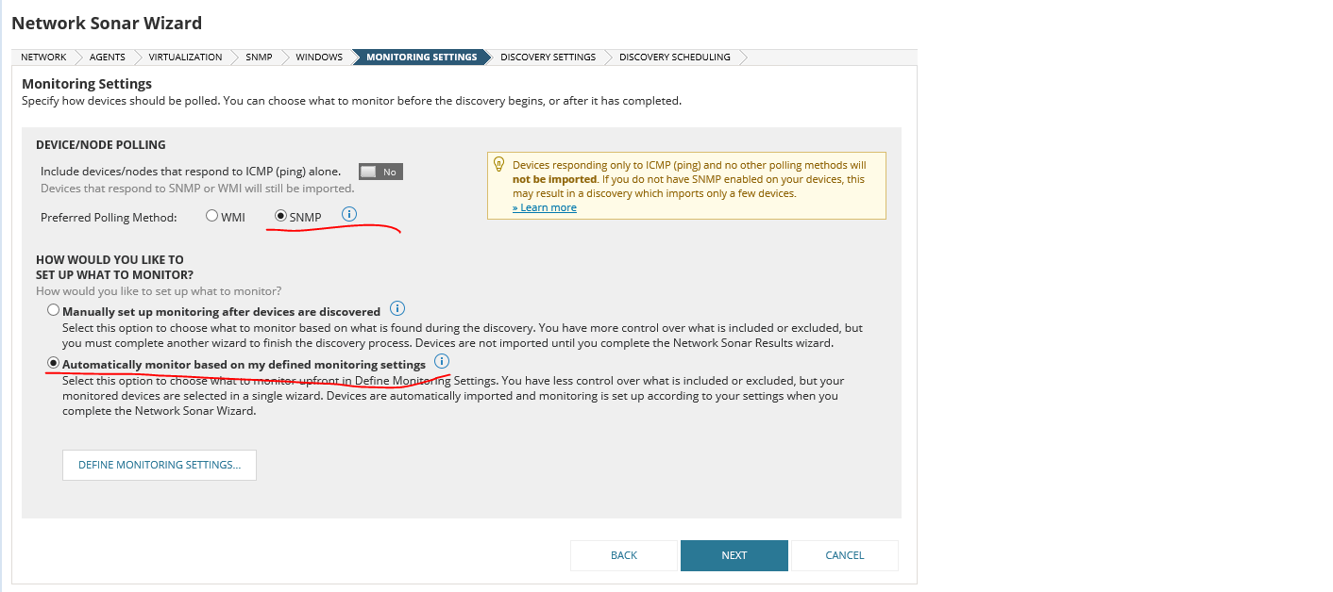

Click **Next** in sequence to complete the configuration.

The monitoring automatically starts if SNMP is enabled on the server.

After the network discovery function is enabled, devices are monitored on the home page.

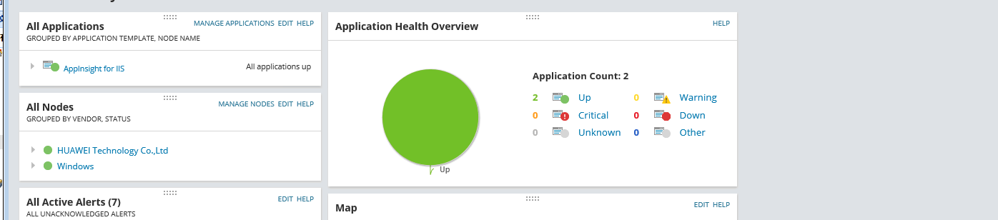

In addition, you can choose **Settings** > **All Settings** > **Add Node** to add a device to be monitored.

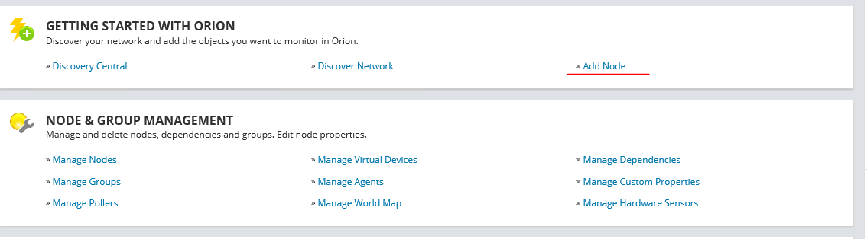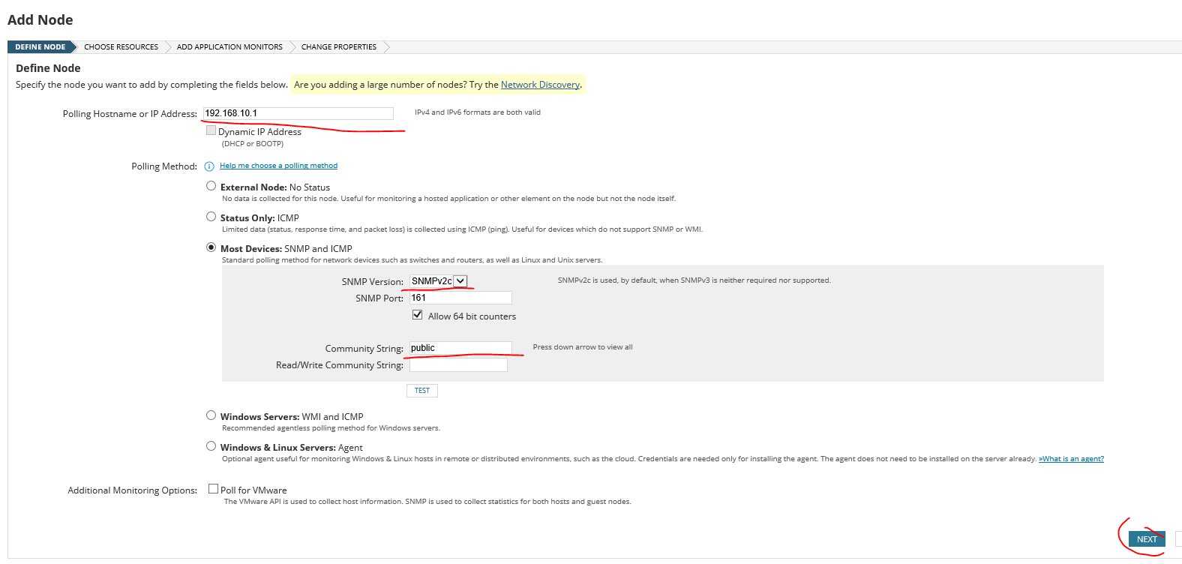

The monitoring results are as follows.

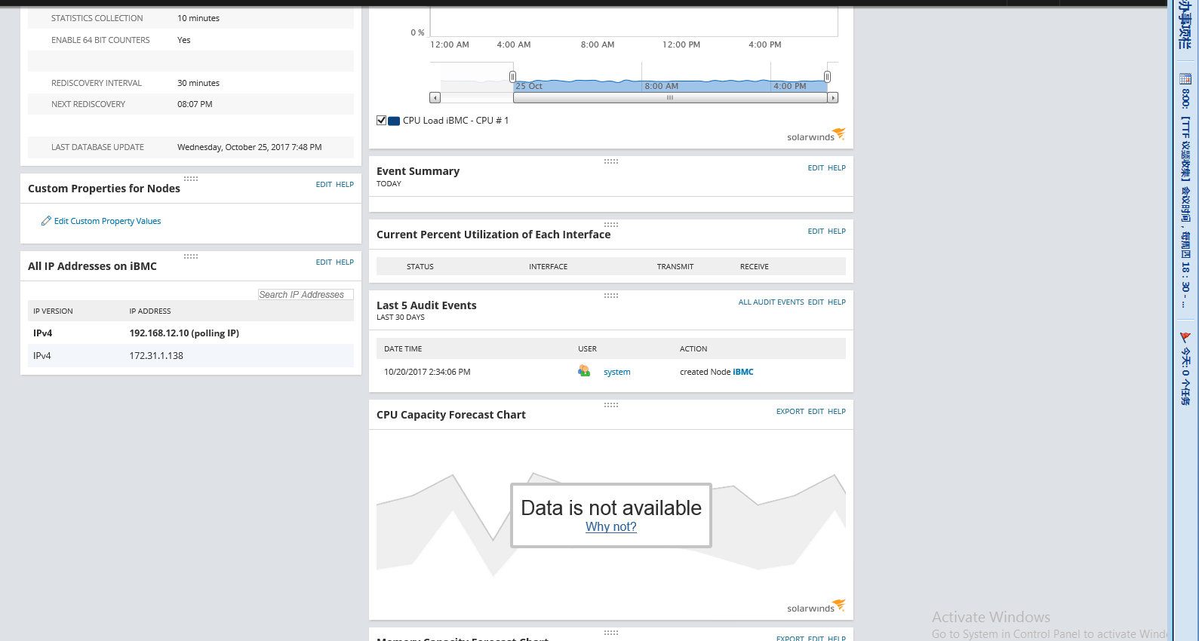

After the trap service of the server is enabled (the trap service is enabled by default), you can choose **ALERTS & ACTIVITY** > **Traps** to view the reported trap messages. (You can also view the trap messages on a node that is not added.)

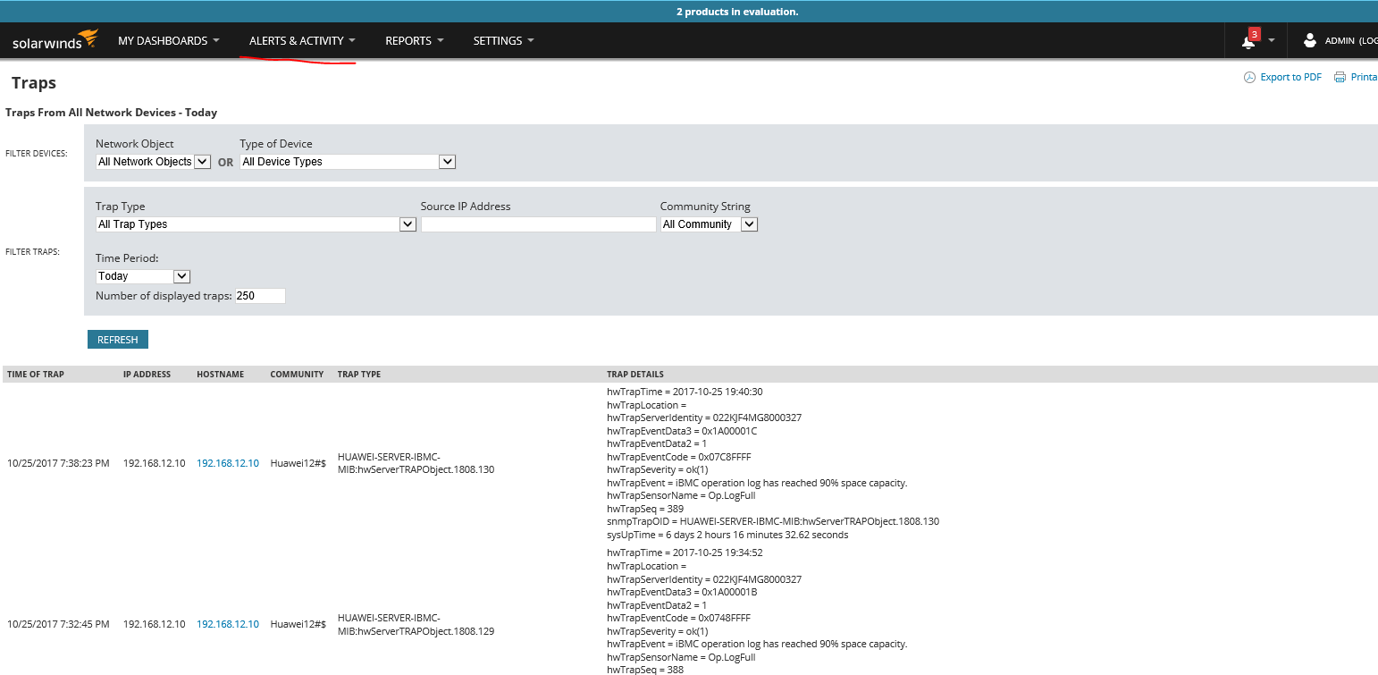

Summary: Operations on Solarwinds are generally simple. However, MIB import is not supported. In current tests, it is found that the MIB library delivered with Solarwinds does not completely adapt to Huawei servers, and fields in some SNMP trap messages cannot be resolved. The CPU and memory information of the iBMC can be monitored, but that of the HMM cannot be monitored. Currently, it is known that MIB library data files need to be created with the technical support of the software vendor and be imported to the software to implement MIB-related updates, and the software does not provide import interfaces that are directly developed. The technical support of the software, however, is only for customers who purchase the software.